Assignment 3 - Part 1 - Project Proposal for Data Visualization Design and Storytelling

Dataset Pitch
The project I propose focuses on analyzing flight delay patterns across the busiest airports in the United States in 2024. The aim is not only to identify when and where delays occur, but also to understand the reasons causing these disruptions. I used a primary flight dataset containing air traffic volume, a regional weather dataset and holiday data. This combined approach allows for a more detailed analysis by examining delays from multiple perspectives such as congestion, external conditions and seasonal trends.
The dataset meets the “Rich Data” criteria as it uses multiple datasets. It also includes temporal variables such as flight date (month, days) and departure time, which enable the analysis of delay patterns across time periods. It includes spatial variables such as origin airports (JFK, LAX), allowing for comparison of performance across locations.
This project has strong narrative potential by showing how delays are influenced by weather, holiday demand and airport congestion, allowing for a clear comparison between environmental and operational factors. The insights can benefit stakeholders such as airline operators and travelers. Airlines and airports can use the findings to improve scheduling and resource allocation, while travelers can make more efficient travel plans.

The MDSI Persona
Based on the OCEAN quiz results, I would describe my role as an Analyst with creative strengths. I prefer approaching tasks in a logical and structured way, focusing on understanding patterns, analyzing information and making sense of data rather than being assertive and lead. I also have a strong appreciation for visual and creative elements, which helps me present insights in a clearer and more engaging way in dashboard designs. This helps me in supporting the team with organizing the Git repository for smooth collaboration as well. This combination allows me to not only analyze data effectively but also communicate findings in a way that is easy to understand.

The Game Plan
As a team, we met on Microsoft Teams to discuss our project timeline and explore dataset ideas. Teams was used for ongoing communication, while Miro was used to organize our ideas, map out the roadmap, and visualize goals. We also discussed and finalized individual roles within the group. To select the dataset for further development, I prepared a short pitch for my dataset story. I shared this on Miro and provided feedback on other’s ideas, including suggestions for improvement. I then voted on my preferred option from all our datasets, by adding sticky notes with the final choice and justification. The dataset with the most votes was selected as our final direction.
Miro Board Contributions:
Link to Miro - https://miro.com/app/board/uXjVGh4-oR4=/?share_link_id=642926626972
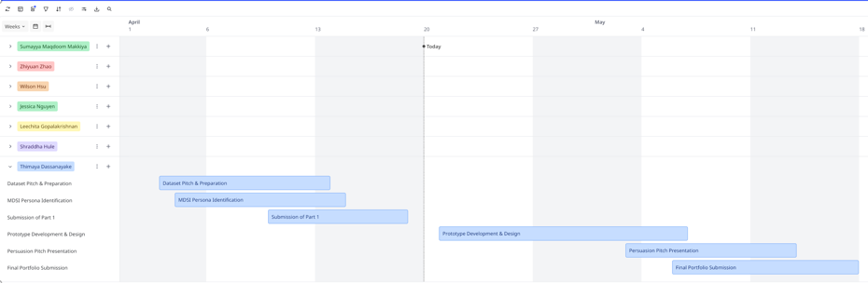

- My Roadmap Timeline -

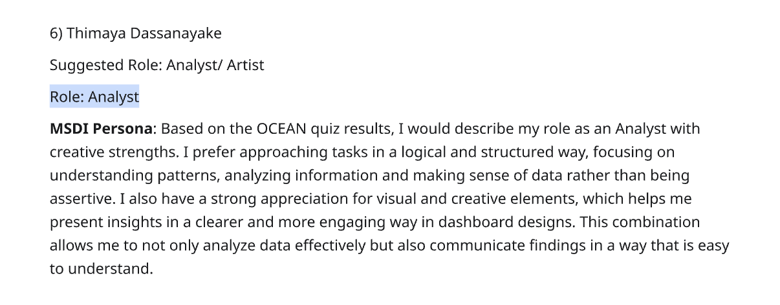
- My role -


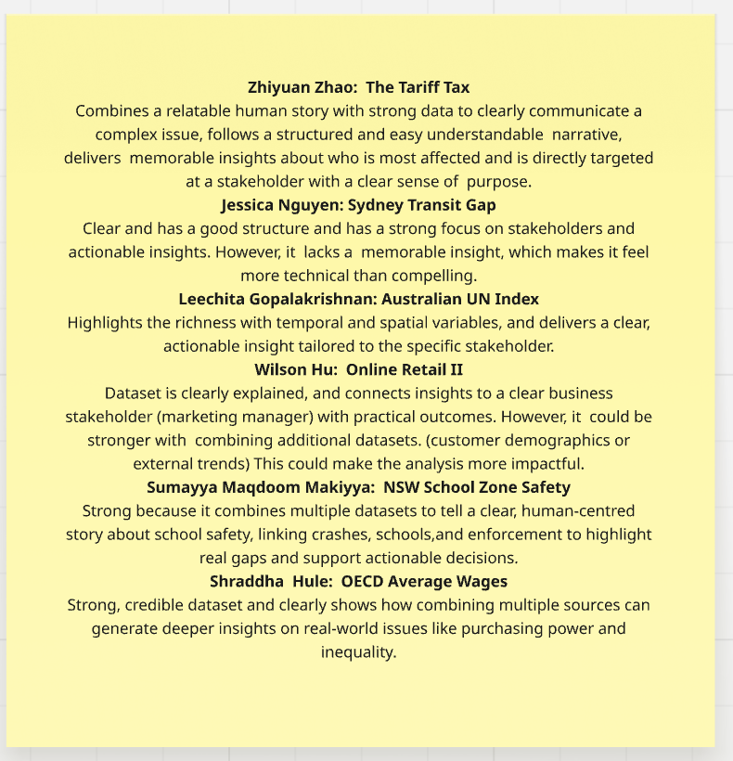
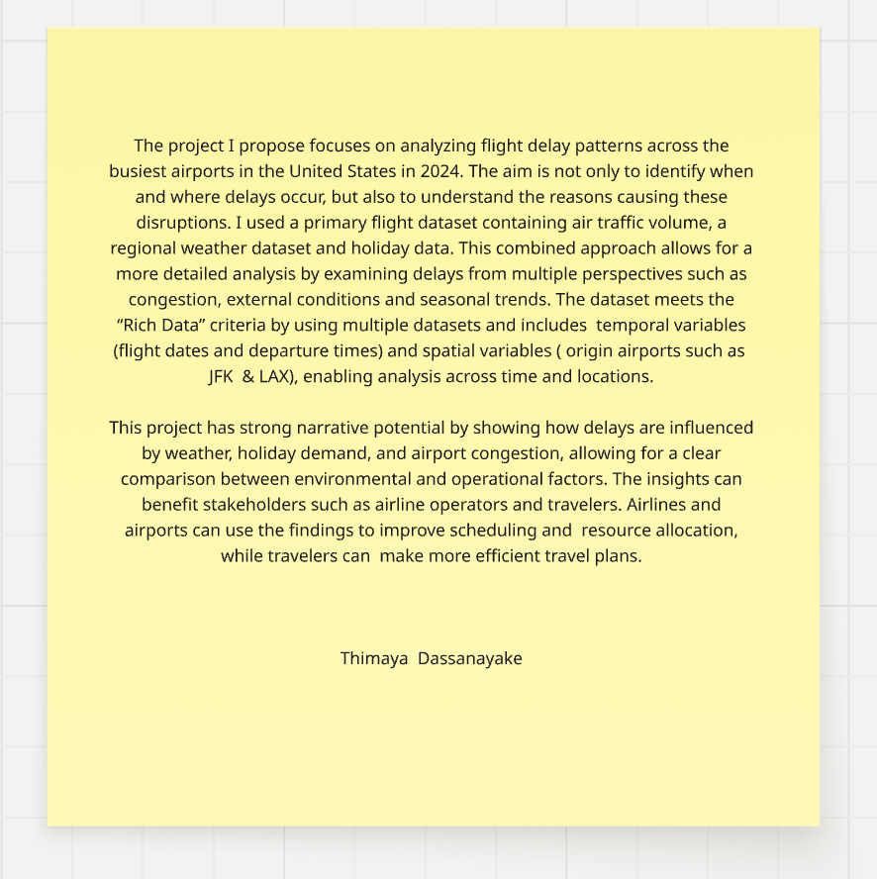
- My Dataset Pitch and vote -

